WEEK 7 ASSIGNMENT:

9]

**App.js:**

import React from 'react';

import ListofPlayers from './ListofPlayers';

import Scorebelow70 from './Scorebelow70';

import OddPlayers from './OddPlayers';

import EvenPlayers from './EvenPlayers';

import ListofIndianPlayers from './ListofIndianPlayers';

function App() {

  const flag = true;

  const players = [

    { name: 'Jack', score: 50 },

    { name: 'Michael', score: 70 },

    { name: 'John', score: 40 },

    { name: 'Ann', score: 61 },

    { name: 'Elisabeth', score: 61 },

    { name: 'Sachin', score: 95 },

    { name: 'Dhoni', score: 100 },

    { name: 'Virat', score: 84 },

    { name: 'Jadeja', score: 64 },

    { name: 'Raina', score: 75 },

    { name: 'Rohit', score: 80 },

  ];

  const IndianTeam = ['Sachin', 'Dhoni2', 'Virat3', 'Rohit4', 'Yuvraj5', 'Raina6'];

  const T20Players = ['First Player', 'Second Player', 'Third Player'];

  const RanjiTrophyPlayers = ['Fourth Player', 'Fifth Player', 'Sixth Player'];

  const IndianPlayers = [...T20Players, ...RanjiTrophyPlayers];

  if (flag === true) {

    return (

      <div>

        <h1>List of Players</h1>

        <ListofPlayers players={players} />

        <hr />

        <h1>List of Players having Scores Less than 70</h1>

        <Scorebelow70 players={players} />

      </div>

    );

  } else {

    return (

      <div>

        <h1>Indian Team</h1>

        <h2>Odd Players</h2>

        <OddPlayers players={IndianTeam} />

        <hr />

        <h2>Even Players</h2>

        <EvenPlayers players={IndianTeam} />

        <hr />

        <h2>List of Indian Players Merged</h2>

        <ListofIndianPlayers IndianPlayers={IndianPlayers} />

      </div>

    );

  }

}

export default App;

**EvenPlayers.js:**  
import React from 'react';

export default function EvenPlayers([, second, , fourth, , sixth]) {

  return (

    <div>

      <li>Second : {second}</li>

      <li>Fourth : {fourth}</li>

      <li>Sixth : {sixth}</li>

    </div>

  );

}

**OddPlayers.js:**

import React from 'react';

const OddPlayers = ([first, , third, , fifth]) => {

return (

<div>

<li>First : {first}</li>

<li>Third : {third}</li>

<li>Fifth : {fifth}</li>

</div>

);

};

export default OddPlayers;

**ListofPlayers.js:**

import React from 'react';

const ListofPlayers = ({ players }) => {

return (

<div>

{players.map((item, index) => (

<li key={index}>

Mr. {item.name} <span>{item.score}</span>

</li>

))}

</div>

);

};

export default ListofPlayers;

**Scorebelow70.js:**import React from 'react'

const Scorebelow70 = ({ players }) => {

const players70 = players.filter(item => item.score <= 70);

return (

<div>

{players70.map((item, index) => (

<li key={index}>

Mr. {item.name} <span>{item.score}</span>

</li>

))}

</div>

);

};

export default Scorebelow70;

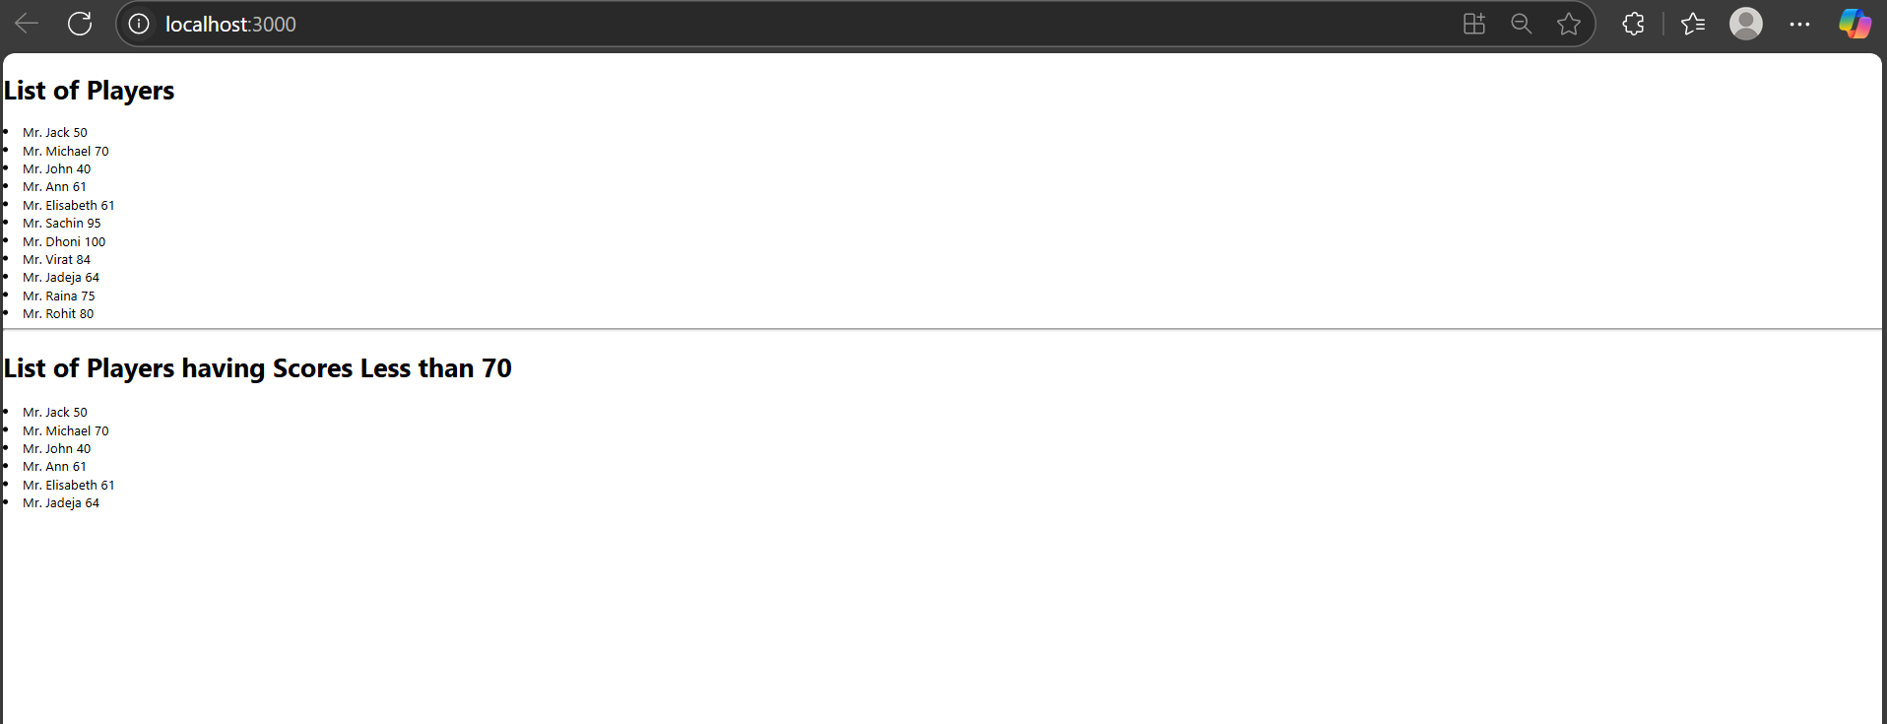

10] **App.js**

import React from 'react';

import './App.css';

function App() {

  const heading = "Office Space";

  const officeList = [

    {

      Name: "DBS",

      Rent: 50000,

      Address: "Chennai",

      Image: "https://img.freepik.com/premium-photo/modern-office-interior_110893-1537.jpg"

    },

    {

      Name: "Regus",

      Rent: 65000,

      Address: "Bangalore",

      Image: "https://img.freepik.com/free-photo/3d-rendering-beautiful-luxury-bedroom-suite-hotel-with-tv-working-table_105762-2008.jpg"

    },

    {

      Name: "SmartWork",

      Rent: 45000,

      Address: "Hyderabad",

      Image: "https://img.freepik.com/premium-photo/modern-office-interior-with-desks_23-2149241284.jpg"

    }

  ];

  return (

    <div>

      <h1>{heading}, at Affordable Range</h1>

      {officeList.map((ItemName, index) => {

        let colors = [];

        if (ItemName.Rent <= 60000) {

          colors.push('textRed');

        } else {

          colors.push('textGreen');

        }

        return (

          <div key={index}>

            <img

              src={ItemName.Image}

              width="25%"

              height="25%"

              alt="Office Space"

            />

            <h1>Name: {ItemName.Name}</h1>

            <h3 className={colors.join(' ')}>Rent: Rs. {ItemName.Rent}</h3>

            <h3>Address: {ItemName.Address}</h3>

            <hr />

          </div>

        );

      })}

    </div>

  );

}

export default App;

**App.css:**

.textRed {

color: red;

font-weight: bold;

}

.textGreen {

color: green;

font-weight: bold;

}

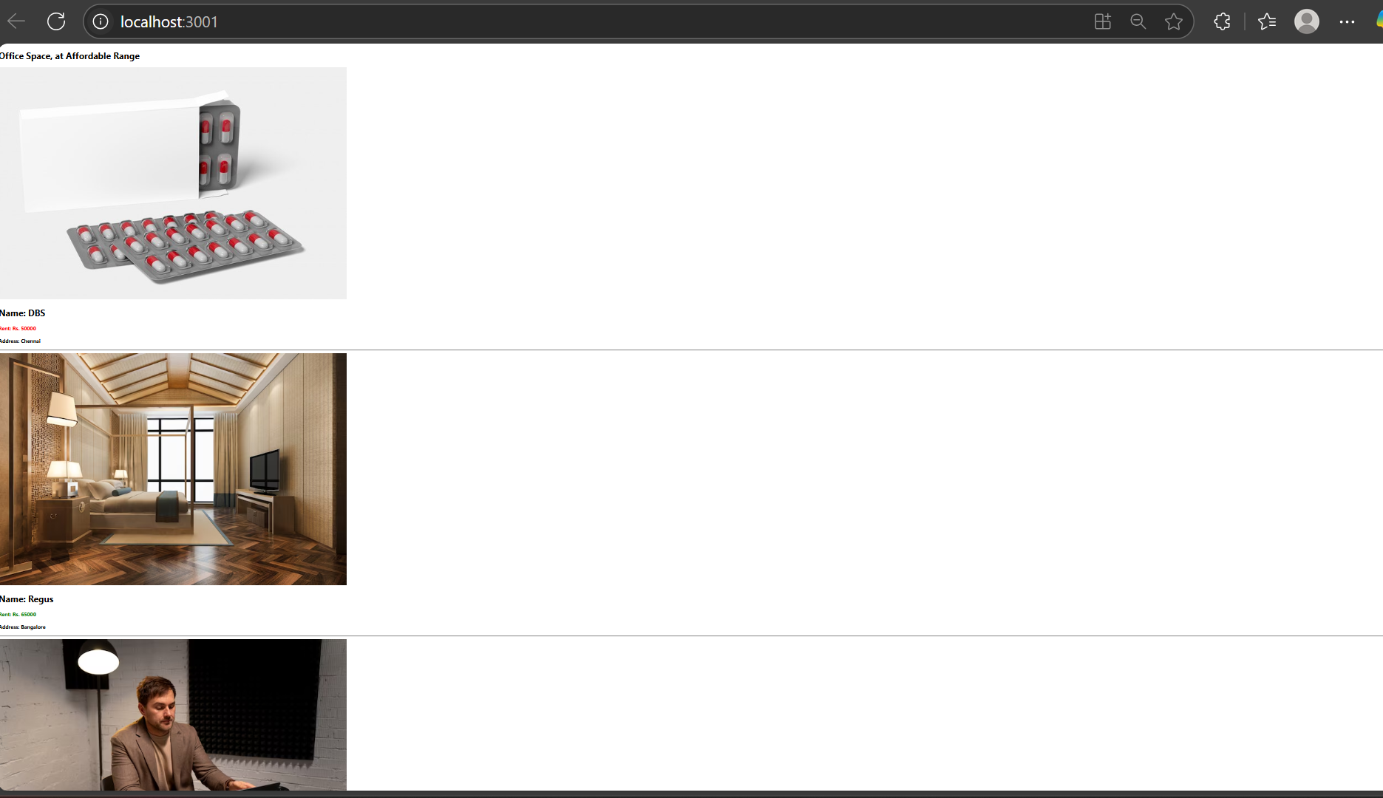

11]

**App.js:**

import React, { useState } from 'react';

import CurrencyConverter from './CurrencyConverter';

import './App.css';

function App() {

  const [count, setCount] = useState(5);

  const increment = () => {

    setCount(prev => prev + 1);

    sayHello();

  };

  const decrement = () => {

    setCount(prev => prev - 1);

  };

  const sayHello = () => {

    alert("Hello Member1!");

  };

  const sayWelcome = (msg) => {

    alert(msg);

  };

  const handleClick = (e) => {

    alert("I was clicked");

  };

  return (

    <div>

      <h3>{count}</h3>

      <button onClick={increment}>Increment</button>

      <br />

      <button onClick={decrement}>Decrement</button>

      <br />

      <button onClick={() => sayWelcome("welcome")}>Say welcome</button>

      <br />

      <button onClick={handleClick}>Click on me</button>

      <h2 style={{ color: 'green' }}>Currency Convertor!!!</h2>

      <CurrencyConverter />

    </div>

  );

}

export default App;

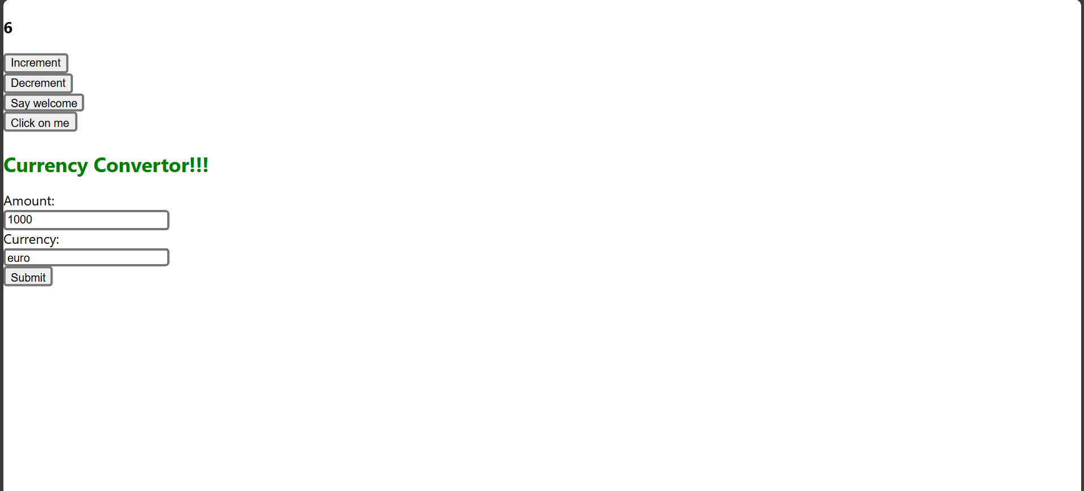

**12]CurrencyConverter.js:**

import React, { useState } from 'react';

function CurrencyConverter() {

const [amount, setAmount] = useState('');

const [currency, setCurrency] = useState('');

const handleAmountChange = (e) => {

setAmount(e.target.value);

};

const handleCurrencyChange = (e) => {

setCurrency(e.target.value);

};

const handleSubmit = (e) => {

e.preventDefault();

if (currency.toLowerCase() === "euro") {

const converted = parseFloat(amount) * 80;

alert(`Converting to Euro Amount is ${converted}`);

} else {

alert("Please enter Euro as currency to convert");

}

};

return (

<form onSubmit={handleSubmit}>

<label>Amount:</label><br />

<input type="text" value={amount} onChange={handleAmountChange} /><br />

<label>Currency:</label><br />

<input type="text" value={currency} onChange={handleCurrencyChange} /><br />

<button type="submit">Submit</button>

</form>

);

}

export default CurrencyConverter;

12]

App.js:

import React, { useState } from 'react';

import LoginButton from './LoginButton';

import LogoutButton from './LogoutButton';

import Greeting from './Greeting';

import GuestPage from './GuestPage';

import UserPage from './UserPage';

function App() {

const [isLoggedIn, setIsLoggedIn] = useState(false);

const handleLoginClick = () => setIsLoggedIn(true);

const handleLogoutClick = () => setIsLoggedIn(false);

const button = isLoggedIn ? (

<LogoutButton onClick={handleLogoutClick} />

) : (

<LoginButton onClick={handleLoginClick} />

);

const content = isLoggedIn ? <UserPage /> : <GuestPage />;

return (

<div style={{ textAlign: 'center', marginTop: '100px' }}>

<Greeting isLoggedIn={isLoggedIn} />

{button}

<hr style={{ margin: '40px 0' }} />

{content}

</div>

);

}

Greeting.js:

import React from 'react';

import UserGreeting from './UserGreeting';

import GuestGreeting from './GuestGreeting';

function Greeting(props) {

const isLoggedIn = props.isLoggedIn;

return isLoggedIn ? <UserGreeting /> : <GuestGreeting />;

}

export default Greeting;

export default App;

Loginbutton.js:

import React from 'react';

function LoginButton(props) {

return (

<button onClick={props.onClick}>

Login

</button>

);

}

export default LoginButton;

LogoutButton.js:

import React from 'react';

function LogoutButton(props) {

return (

<button onClick={props.onClick}>

Logout

</button>

);

}

export default LogoutButton;

UserGreeting.js:

import React from 'react';

function UserGreeting() {

return <h1>Welcome back</h1>;

}

export default UserGreeting;

GuedtGreeting.js:

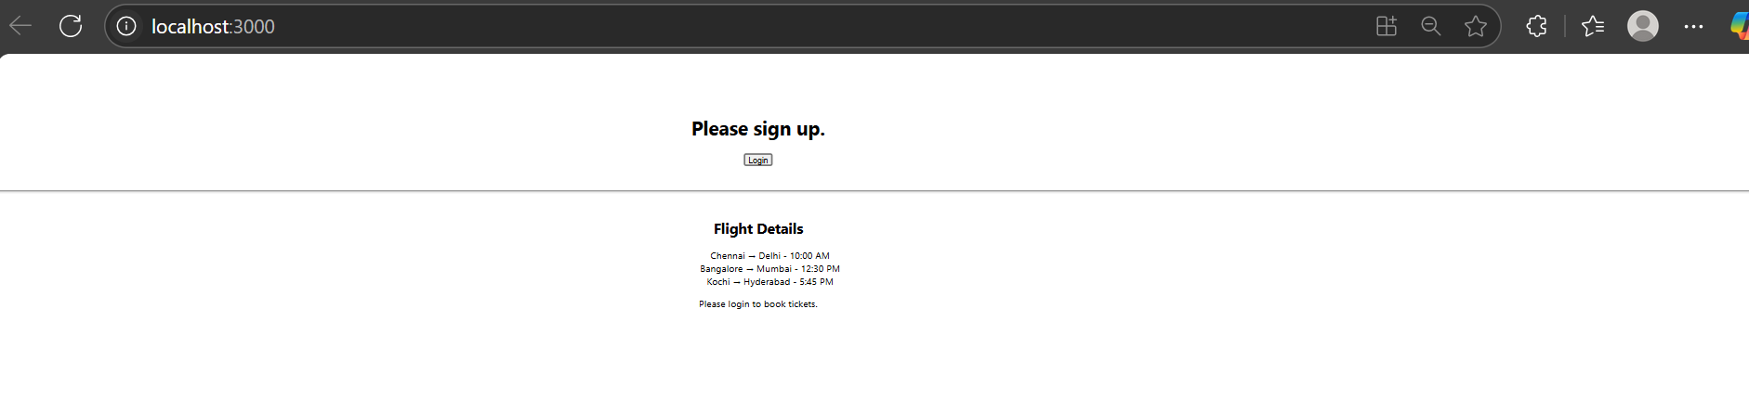

*GuestGreeting.js:*

import React from 'react';

function GuestGreeting() {

return <h1>Please sign up.</h1>;

}

export default GuestGreeting;

GuestPage.js

import React from 'react';

function GuestPage() {

return (

<div>

<h2>Flight Details</h2>

<ul>

<li>Chennai → Delhi - 10:00 AM</li>

<li> Bangalore → Mumbai - 12:30 PM</li>

<li> Kochi → Hyderabad - 5:45 PM</li>

</ul>

<p>Please login to book tickets.</p>

</div>

);

}

export default GuestPage;

13]

App.js:

import React from 'react';

import './App.css';

const books = [

{ id: 101, bname: 'Master React', price: 670 },

{ id: 102, bname: 'Deep Dive into Angular 11', price: 800 },

{ id: 103, bname: 'Mongo Essentials', price: 450 },

];

const blogs = [

{

id: 1,

title: 'React Learning',

author: 'Stephen Biz',

content: 'Welcome to learning React!',

},

{

id: 2,

title: 'Installation',

author: 'Schewzdenier',

content: 'You can install React from npm.',

},

];

const courses = [

{ id: 1, cname: 'Angular', date: '4/5/2021' },

{ id: 2, cname: 'React', date: '6/3/2021' },

];

function App() {

const bookdet = (

<ul>

{books.map((book) => (

<div key={book.id}>

<h3>{book.bname}</h3>

<h4>{book.price}</h4>

</div>

))}

</ul>

);

const content = (

<ul>

{blogs.map((blog) => (

<div key={blog.id}>

<h3>{blog.title}</h3>

<b>{blog.author}</b>

<p>{blog.content}</p>

</div>

))}

</ul>

);

const coursedet = (

<ul>

{courses.map((course) => (

<div key={course.id}>

<h3>{course.cname}</h3>

<h4>{course.date}</h4>

</div>

))}

</ul>

);

return (

<div className="container">

<div className="box mystyle1">

<h1>Course Details</h1>

{coursedet}

</div>

<div className="box st2">

<h1>Book Details</h1>

{bookdet}

</div>

<div className="box v1">

<h1>Blog Details</h1>

{content}

</div>

</div>

);

}

export default App;

App.css:

.container {

display: flex;

justify-content: space-around;

padding: 40px;

font-family: Arial, sans-serif;

}

.box {

width: 30%;

padding: 20px;

}

.mystyle1 {

border-right: 4px solid green;

}

.st2 {

border-right: 4px solid green;

}

.v1 {

}

